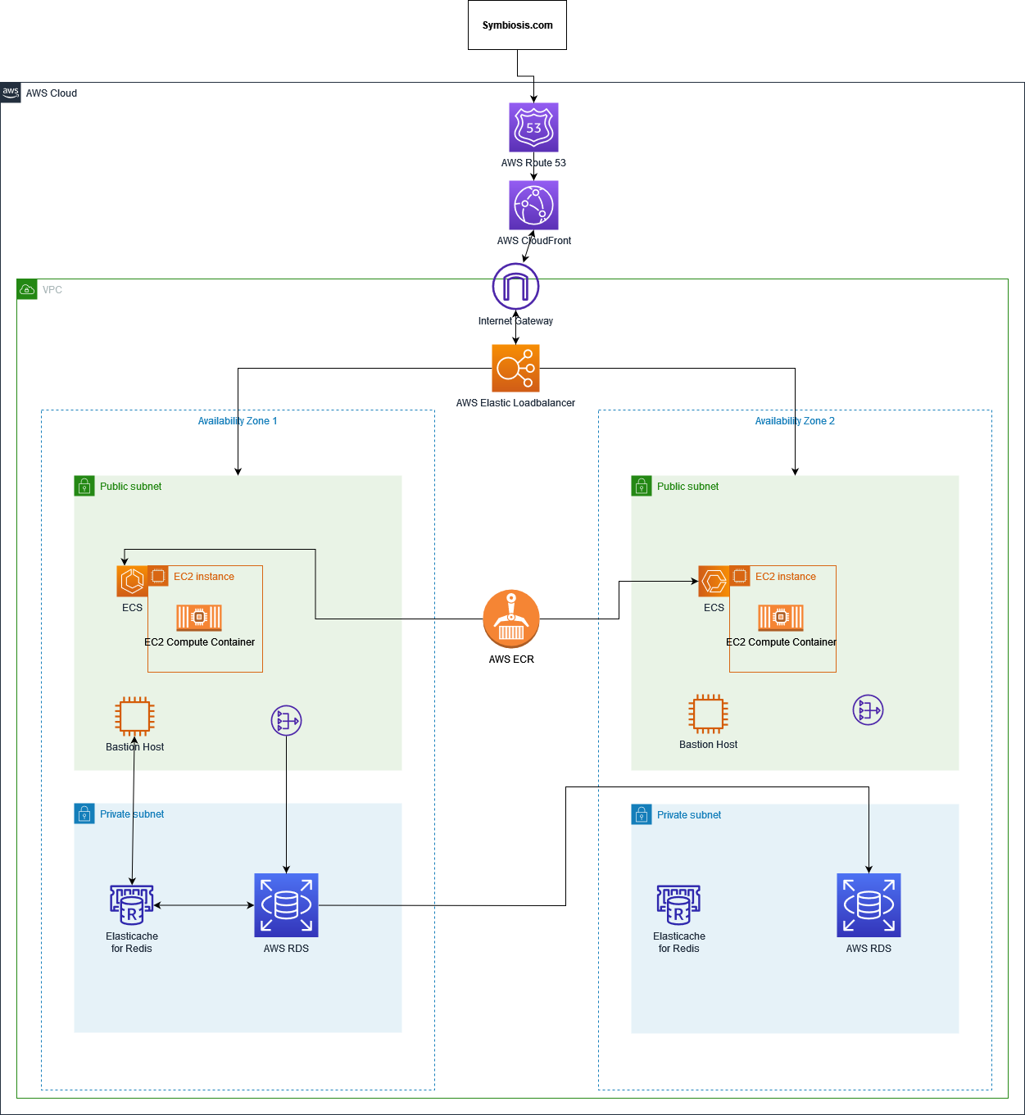

I have crafted a simple diagram to showcase what possible AWS cloud architecture could be used by symbiosis in order to migrate their on-premises system to the cloud with as few issues as possible. The components are as follows

* AWS Route53
  + Highly available and scalable DNS system.
* AWS CloudFront
  + Low latency and scalability
* Elastic Load Balancer
  + Distribution of HTTPS traffic enabling distribution of load
* AWS Elastic Container Service
  + Microservice solution used to scale containerized applications in EC2 instances
* AWS EC2
  + On-Demand instances can be called and spun up by ECS in order to scale to demand.
* AWS Availability Zone
  + Two availability zones to ensure availability and ability to meet demand. Possible to increase to more regions or more Availability zones if needed.
* AWS Elastic Cache – Redis
  + Primarily used as a caching tool in order to more quickly fetch and serve any information that may be used by clients/users
* AWS RDS
  + Managed service for Databases that is scalable.

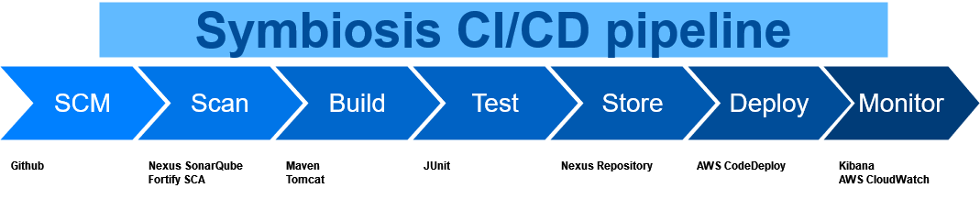

The overview for the CI/CD pipeline is as follows

Using Atlassian Bamboo as the Pipeline tool

Github being the source code repository, everytime code is pushed to the Github repo Bamboo begins the process.  
Firstly pulling the code from the SCM and running it through security scanning in this case

Nexus SonarQube To find vulnerabilities in code libraries and components

Fortify SCA to find vulnerabilities in code itself and to more easily rank them in terms of the seriousness of the found vulnerabilities.

A threshold can be set in order to determine whether or not the build will continue based upon the number of critical vulnerabilities or not.

Testing of critical software functions done by Maven and Junit

Storage of build artifact within Nexus Repository

AWS CodeDeploy can then be used in order to monitor the repository for the latest build in order to deploy the latest version. This can be done by either killing any existing instances or by deploying the latest version as each service is terminated and a new one is deployed.

Monitoring by utilizing Kibana and cloud services by using AWS CloudWatch